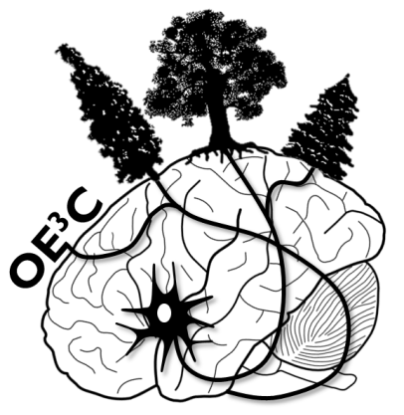44th Ontario Ecology, Ethology and Evolution Colloquium

University of Guelph, Guelph, Ontario

May 8-10, 2014

**PAYMENT INVOICE**

**Date of Issue: May 15, 2014**

**Delegate’s Name: Ken A. Thompson**

**Institution: University of Guelph**

**PayPal Receipt Number: GL Coding:** 30101460040043400000064372

|  |  |  |  |  |
| --- | --- | --- | --- | --- |
| ✔ | ($70) Early Registration (Student / Post-Doc) |  | ($100) Early Registration (Faculty) | |
|  |  |  |  | | |
|  | ($80) Registration (Student / Post-Doc) |  | ($110) Registration (Faculty) |
|  |  | | | | |
|  | ($15) T-shirt | | | | |

**Signature (Organizing Committee Member): ______________________________________**

OE3C 2014 Organizing Committee / http://www.uoguelph.ca/oe3c2014 / oe3c2014@gmail.com

44th Ontario Ecology, Ethology and Evolution Colloquium

University of Guelph, Guelph, Ontario

May 8-10, 2014

**PAYMENT INVOICE**

**Date of Issue: May 15, 2014**

**Delegate’s Name: Dylan Sora**

**Institution: University of Guelph**

**PayPal Receipt Number: GL Coding:** 30101460040043400000064372

|  |  |  |  |  |
| --- | --- | --- | --- | --- |
| ✔ | ($70) Early Registration (Student / Post-Doc) |  | ($100) Early Registration (Faculty) | |
|  |  |  |  | | |
|  | ($80) Registration (Student / Post-Doc) |  | ($110) Registration (Faculty) |
|  |  | | | | |
|  | ($15) T-shirt | | | | |

**Signature (Organizing Committee Member): ______________________________________**

OE3C 2014 Organizing Committee / http://www.uoguelph.ca/oe3c2014 / oe3c2014@gmail.com